Greeble Generator

Code works in 3 passes.

STEP 1

Given a collection of faces for each face insert “boxes” using a non random placement algorithm such as attractors to the corners.

A schematic of these boxes is shown in Figure 1

Figure 1
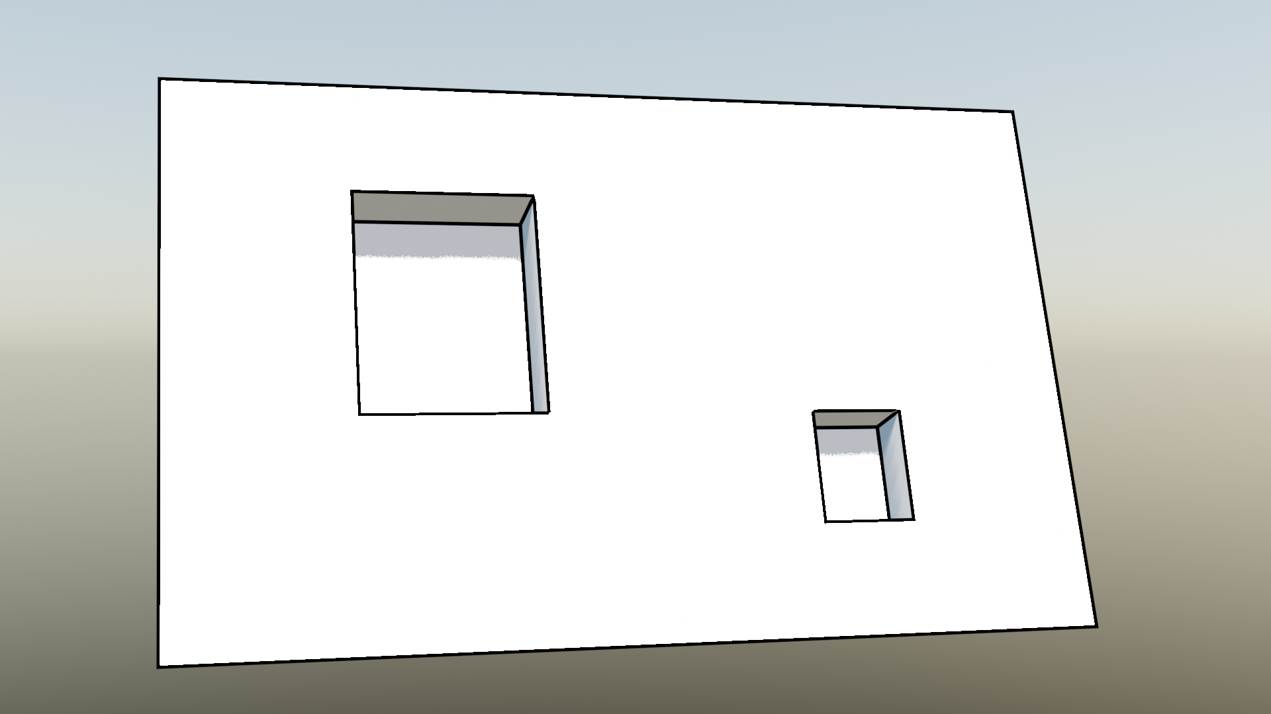

STEP 2

For each box fill with greeble via algorithms which are functions and which are randomly swapped out.

Examples for function

- Random Flat Cylinders distributed by Poisson distributions
- UV spheres distributed randomly penetrating the surface to resemble domes
- Other possibilities

For the first pass in coding, use these two

Figure 2

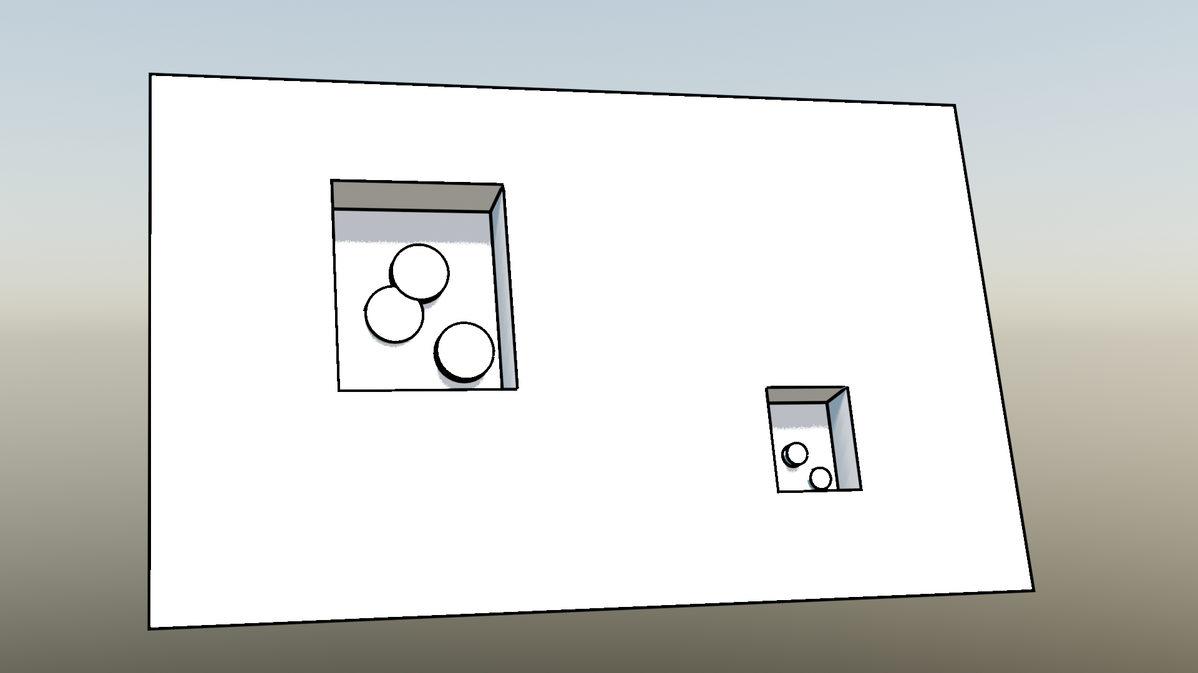

STEP 3

Connectors are drawn between the boxes with random joint placement and joint covers

Figure 3

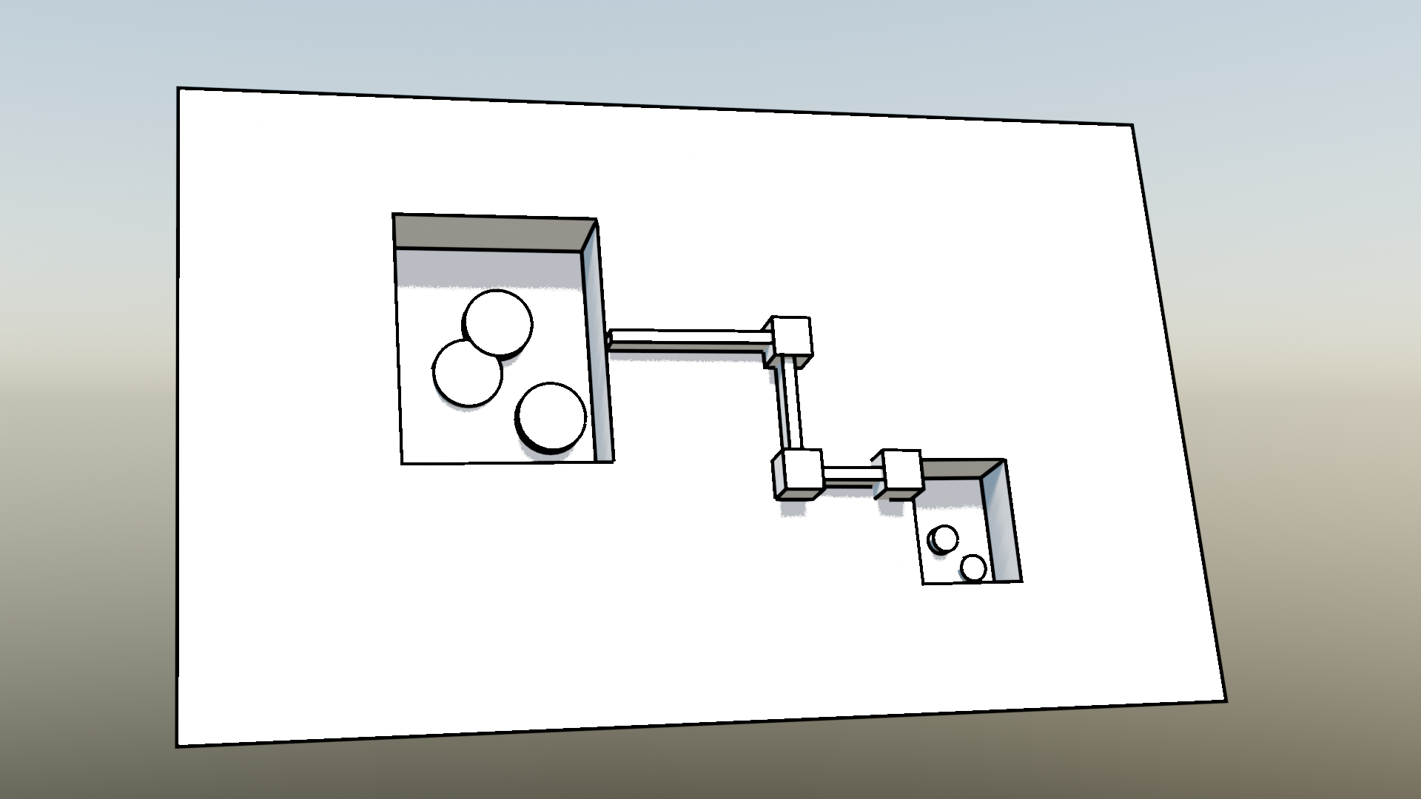

Code Notes

Path resolution:

_dir = os.path.dirname(bpy.context.space_data.text.filepath)
if _dir not in sys.path:
sys.path.append(_dir)

Program should have a runnable main.py

